Culture Experiment PDGFBR Mediated Differentiation

Rationale:

Cells: Sya

Media: DF10, SFM +0.2% Serum

Protocol:
Plate mouse aortic SMC (1.2 x 10⁴ density)

Day 0 Change (at 70% confluency) media to SFM + 0.2% Serum w/ or w/o chol

Day 3 72h – Wash 2x with PBS then add PDGF BB or DD

Day 5 24h later – Wash 2x with PBS then mRNA extraction with Trizol
Keep conditioned media in -80

PCR:
- SMC marker genes + 18s or B2M (SMaA, MHC, 22a, calponin)

- MSC markers (sca1, CD105)

- Macrophage markers (mac2)

4. MF markers (periostin, coll 1, 3, 4, 8, 15)

5. Inflammatory markers: IL1b, Mcp1, CCL20

Notes:
Plate cells on 100mm dishes (10 ml of media)
Plate SMCs on 6 well plates in triplicate for each treatment.

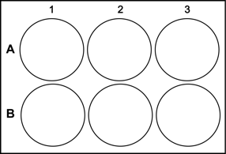
vehicle Cholesterol then DD – day 3
DD (30ng/mL) -day 3 Cholesterol AND DD – day 0

